**Basic Shell Commands:**

**1:**



**2:**



**3:**



**4:**

**rmdir** - remove empty directories

Remove the DIRECTORY(ies), if they are empty

**rm** - remove files or directories

rm removes each specified file. By default, it does not remove directories.

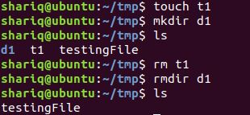

**5:**

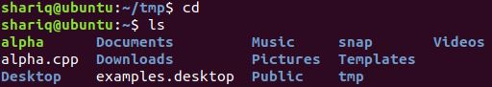

**6:**

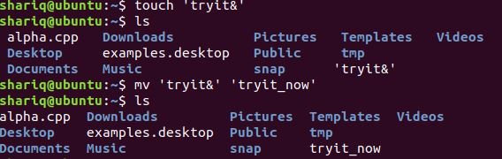

**7:**



**Output: screen cleared**

**8:**

**a)**



**b)**

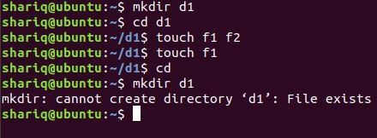

**QUESTIONS:**

**1:**



**2:**

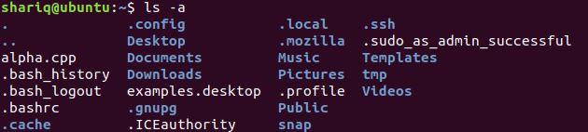

**3:**

1st way is going one by one and removing by using **rmdir**

other way is :

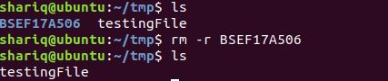

**4:**

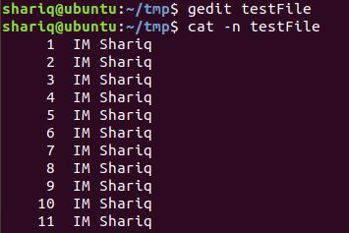

**5:**

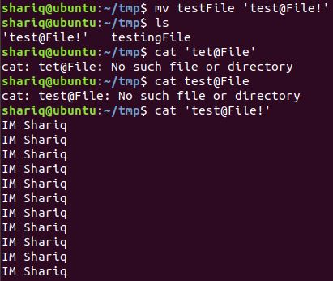

**6:**

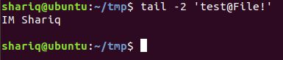

**7:**

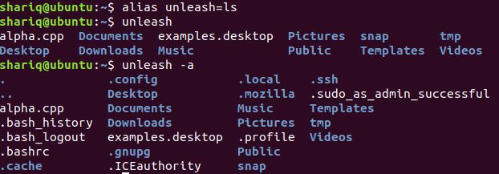

**8:**



**9:**

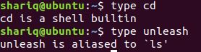

**10:**



**Absolute / Relative Path**

**1 & 2:**

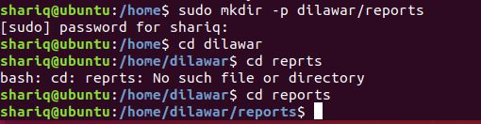

**3:**





File1 created:



**4:**

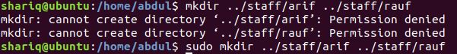

**5:**



**6:**



**7:**



**8:**



**9:**

